When user presses Confirm in Reminder Details Page it leads a wrong page; it leads to the Reminders Page instead of the Reminders Details Page. Make it so that after the user presses confirm it leads to the Reminders Details Page.(NOT the Reminders Page)

Akilan: As I mentioned earlier, Will implemented it during server implementation

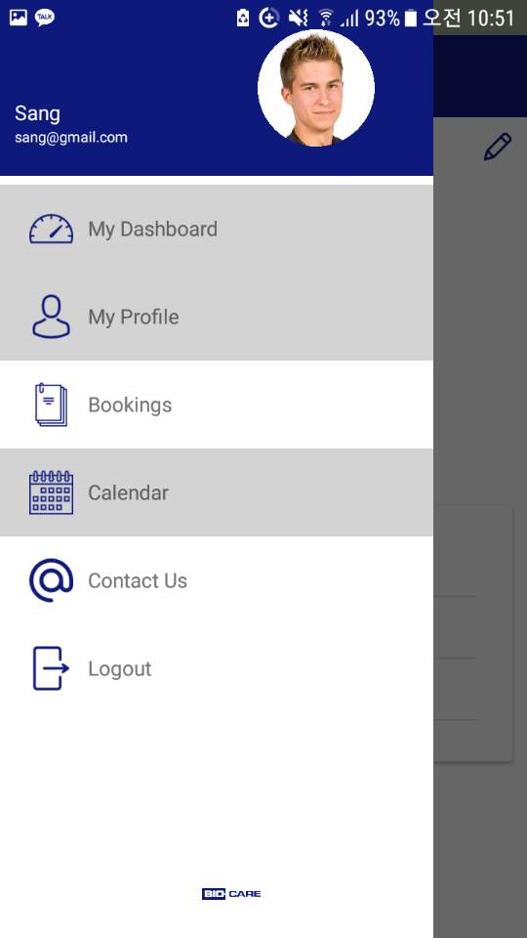

Make the font of the words(My Dashboard, My Profile, Bookings, Calendar, Contact Us, Logout) into blue (same color as the icons)

Akilan: I’ll update this ASAP.

My Profile Page:

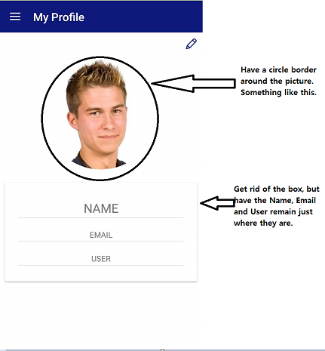  
Akilan: Corrected Please check

Error #2:

Also, for all the four pages(Completed Bookings Page, Scheduled Bookings Page, Reminders Page, Notifications Page), when the user presses on the information button( that leads to the details page) twice quickly, it opens the details page twice.

Akilan: Corrected Please check